>SECIS_of_SelR.AUREOCOCCUS_ANOPHAGEFFERENS.ID located on SCAFFOLD_7 strand + positions 1213218,210547 [#Utilizamos la opción “loose canonical and non-canonical”]

Aureococcus Scaffold 7

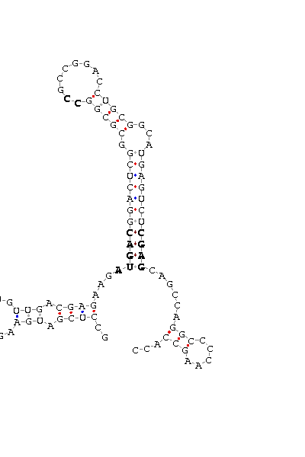
1 unnamed: 3704 3798
upstemen:-14.30 fullstructen: -24.10
GCCUCGAUGA AGUUGGU GUUGACGAGAAG AUGAC GGACUCGGCGCGG CC GCCGGACCU GCGGCAUGAGUCU CGAG CAG CCAGGCC CCAAGCCACC
COVE score: 9.06
(Recommended threshold for COVE: 15)

